# IOT HOLIDAY ASSIGNMENT

**M. Kavya 2211CS020312AIML-DELTA**

# Write a Embedded C Program to Create a Weather Reporting System that provides real- time environmental data to users.

INSTALL **LiquidCrystal_I2C** LIBRARY

#include <Wire.h>

#include <LiquidCrystal_I2C.h> #include "DHT.h"

#define DHTPIN 2 // Pin connected to DHT sensor

#define DHTTYPE DHT22 // Type of DHT sensor (DHT22 or DHT11)

DHT dht(DHTPIN, DHTTYPE);

LiquidCrystal_I2C lcd(0x27, 16, 2); // Set the LCD I2C address to 0x27

void setup() { lcd.init(); lcd.backlight();

dht.begin(); lcd.setCursor(0, 0);

lcd.print("Weather System"); lcd.setCursor(0, 1); lcd.print("Initializing..."); delay(2000);

lcd.clear();

}

void loop() { float temp =

dht.readTemperature(); float humidity = dht.readHumidity();

if (isnan(temp) || isnan(humidity)) { lcd.setCursor(0, 0); lcd.print("Sensor Error”);

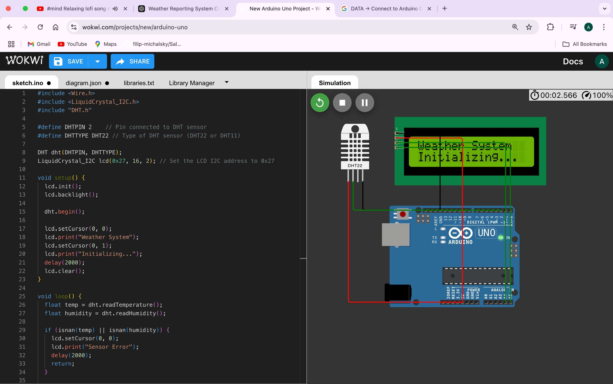

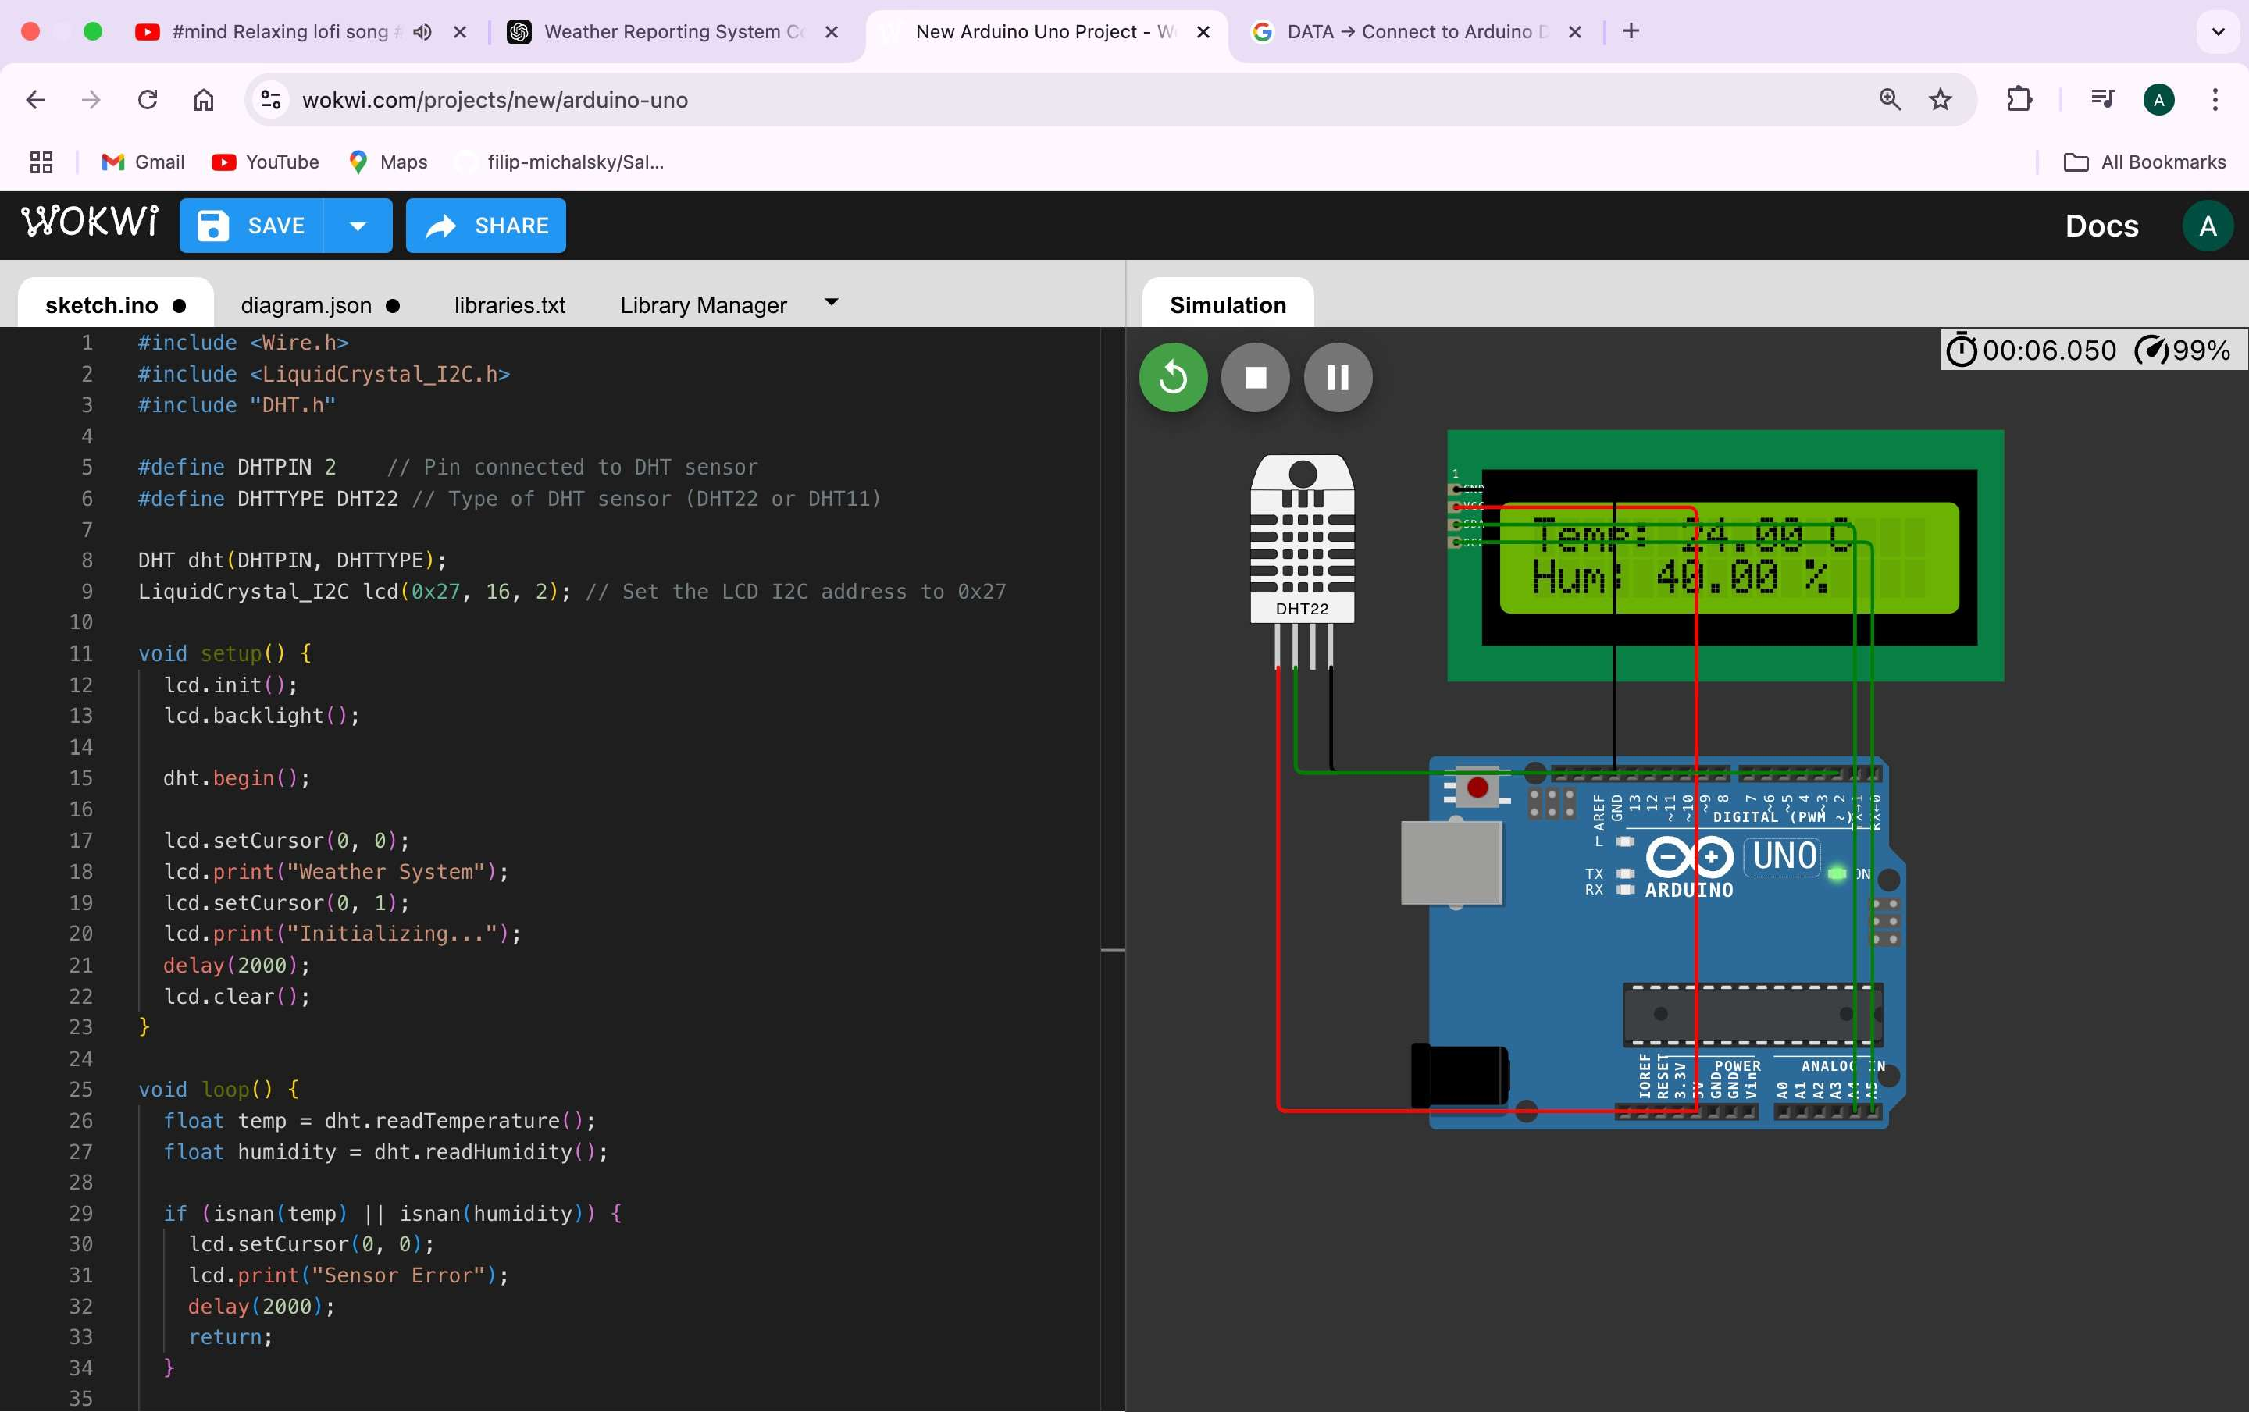

# Write a Embedded C Program to Create a Home Automation System that simplifies daily routines (Any 2 Devices) by controlling devices remotely.

#define LIGHT_PIN 3

#define FAN_PIN 5

#define BUTTON_LIGHT 7

#define BUTTON_FAN 8

int lightState = 0; int fanState = 0;

void setup() {

// Initialize pins pinMode(LIGHT_PIN, OUTPUT); pinMode(FAN_PIN, OUTPUT);

pinMode(BUTTON_LIGHT, INPUT_PULLUP); // Button with internal pull-up resistor

pinMode(BUTTON_FAN, INPUT_PULLUP); // Button with internal pull-up resistor

// Initialize serial communication Serial.begin(9600);

Serial.println("Home Automation System Initialized"); Serial.println("Commands: TURN_ON_LIGHT, TURN_OFF_LIGHT, TURN_ON_FAN, TURN_OFF_FAN");

}

void loop() {

// Debug: Check if the button states are being read Serial.print("Button Light: "); Serial.println(digitalRead(BUTTON_LIGHT)); // Print button state for light

Serial.print("Button Fan: "); Serial.println(digitalRead(BUTTON_FAN)); // Print button state for fan

// Read button states for manual control

if (digitalRead(BUTTON_LIGHT) == LOW) { if (lightState == 0) {

lightState = 1;

fanState = 0; // Turn off the fan digitalWrite(LIGHT_PIN, HIGH); digitalWrite(FAN_PIN, LOW);

Serial.println("Light turned ON, Fan turned OFF");

}

delay(300); // Debounce delay

}

if (digitalRead(BUTTON_FAN) == LOW) { if (fanState == 0) {

fanState = 1;

lightState = 0; // Turn off the light digitalWrite(LIGHT_PIN, LOW); digitalWrite(FAN_PIN, HIGH);

Serial.println("Fan turned ON, Light turned OFF");

}

delay(300); // Debounce delay

}

// Check for serial commands to control the devices if (Serial.available()) {

String command = Serial.readStringUntil('\n'); command.trim();

if (command == "TURN_ON_LIGHT") { lightState = 1;

fanState = 0; // Turn off the fan digitalWrite(LIGHT_PIN, HIGH); digitalWrite(FAN_PIN, LOW); Serial.println("Light turned ON, Fan turned OFF");

} else if (command == "TURN_OFF_LIGHT") { lightState = 0;

digitalWrite(LIGHT_PIN, LOW); Serial.println("Light turned OFF");

} else if (command == "TURN_ON_FAN") { fanState = 1;

lightState = 0; // Turn off the light

digitalWrite(LIGHT_PIN, LOW); digitalWrite(FAN_PIN, HIGH);

Serial.println("Fan turned ON, Light turned OFF");

} else if (command == "TURN_OFF_FAN") { fanState = 0;

digitalWrite(FAN_PIN, LOW); Serial.println("Fan turned OFF");

} else {

Serial.println("Unknown command! Use TURN_ON_LIGHT, TURN_OFF_LIGHT, TURN_ON_FAN, TURN_OFF_FAN");

}

}

// Status Display Serial.print("Light: ");

Serial.print(lightState ? "ON" : "OFF"); Serial.print(", Fan: "); Serial.println(fanState ? "ON" : "OFF"); delay(1000); // Update every second

}

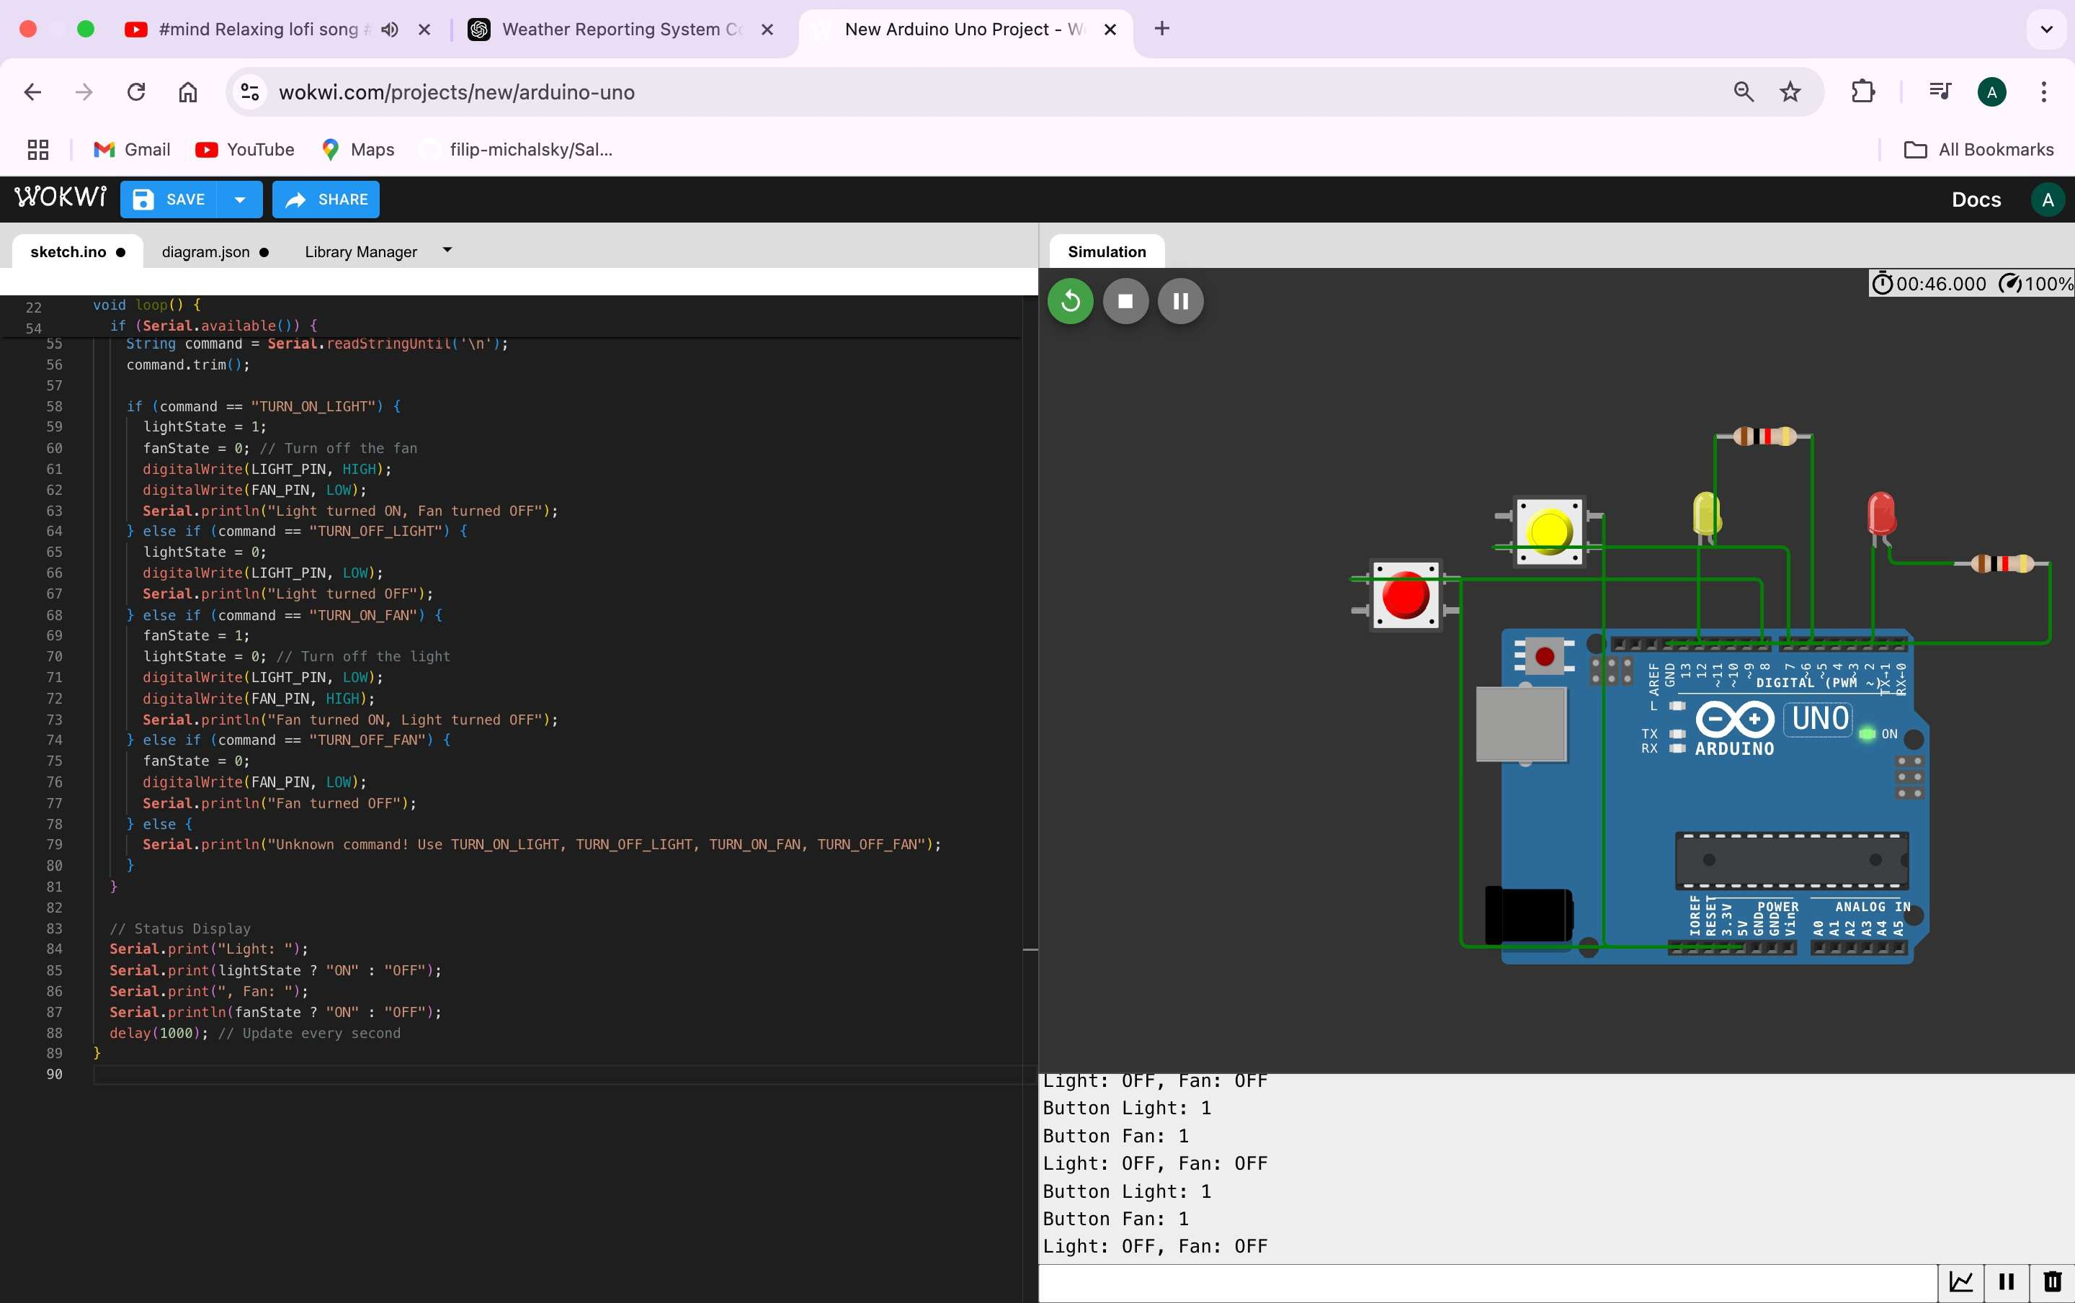

# Write a Embedded C Program to Create an Air Pollution Monitoring System that tracks air quality levels in real-time to ensure a healthier environment.

#include <Wire.h>

#include <LiquidCrystal_I2C.h>

#define SENSOR_PIN A0 // MQ-135 sensor or potentiometer connected to analog pin A0

#define LED_PIN 13 // LED pin for air quality indication

LiquidCrystal_I2C lcd(0x27, 16, 2); // I2C address 0x27, 16x2 LCD

void setup() {

// Initialize LCD lcd.begin(16, 2); lcd.backlight();

// Initialize Serial Communication Serial.begin(9600);

// Set the LED pin as OUTPUT pinMode(LED_PIN, OUTPUT);

// Welcome message on LCD lcd.setCursor(0, 0); lcd.print("Air Quality"); lcd.setCursor(0, 1); lcd.print("Monitoring");

delay(2000); lcd.clear();

}

void loop() {

// Simulate dynamic sensor values int sensorValue = random(300, 800);

// Convert sensor value to air quality percentage int airQuality = map(sensorValue, 0, 1023, 0, 100);

// Print data to Serial Monitor Serial.print("Sensor Value: "); Serial.print(sensorValue); Serial.print(" | Air Quality: "); Serial.print(airQuality); Serial.println("%");

// Display air quality percentage on LCD lcd.setCursor(0, 0);

lcd.print("Air Quality: "); lcd.print(airQuality);

lcd.print("% "); // Padding to avoid artifacts

// Determine air quality status if (airQuality > 70) {

// Good air quality lcd.setCursor(0, 1); lcd.print("Status: Good ");

digitalWrite(LED_PIN, LOW); // LED off (Good air quality)

} else if (airQuality > 40) {

// Moderate air quality lcd.setCursor(0, 1); lcd.print("Status: Moderate");

digitalWrite(LED_PIN, LOW); // LED off (Optional for moderate)

} else {

// Poor air quality lcd.setCursor(0, 1); lcd.print("Status: Poor ");

digitalWrite(LED_PIN, HIGH); // LED on (Poor air quality)

}

delay(2000); // Update every 2 seconds

}

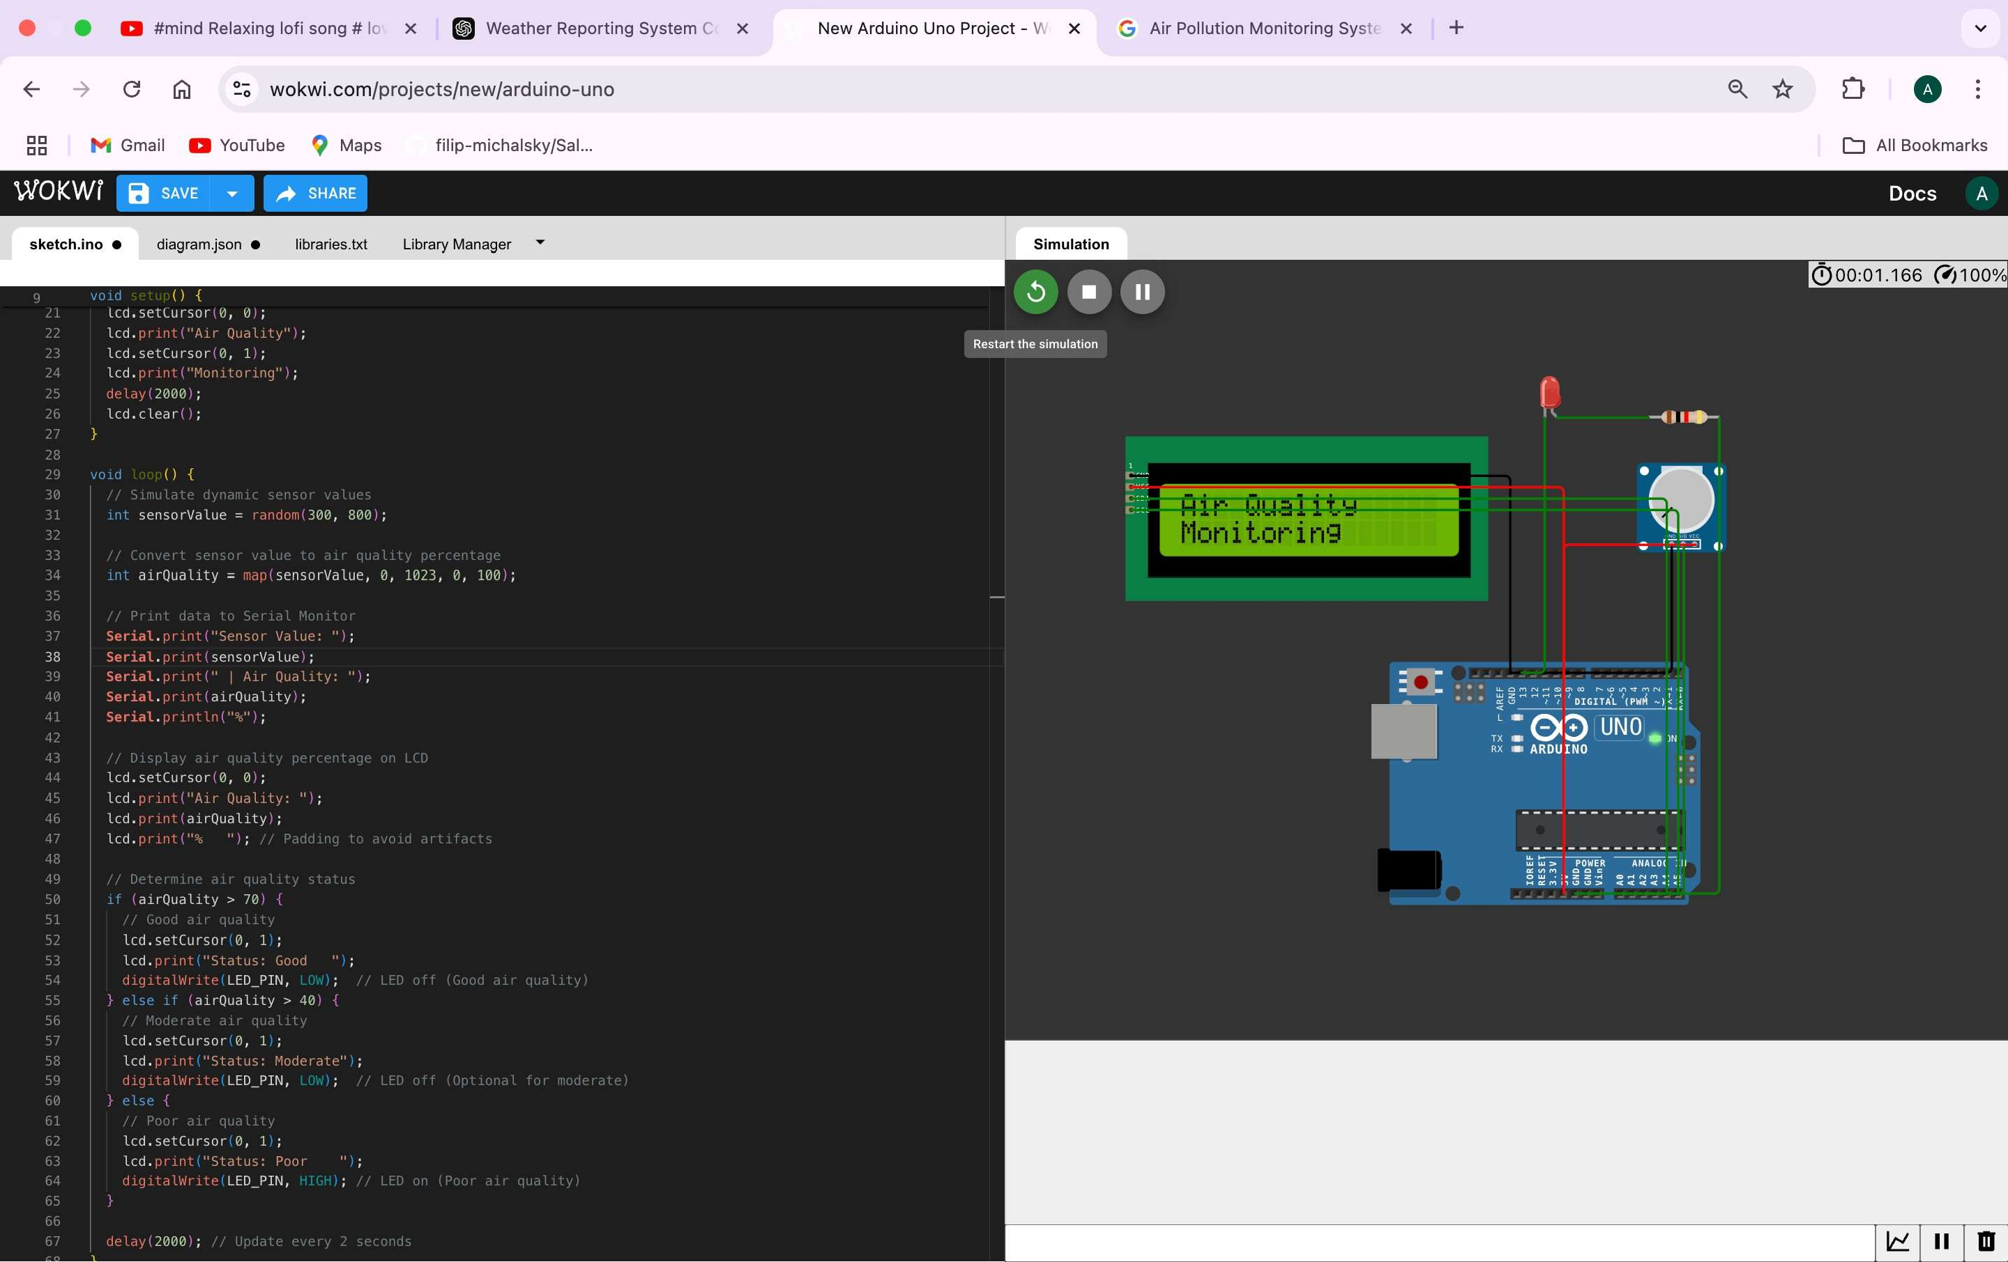

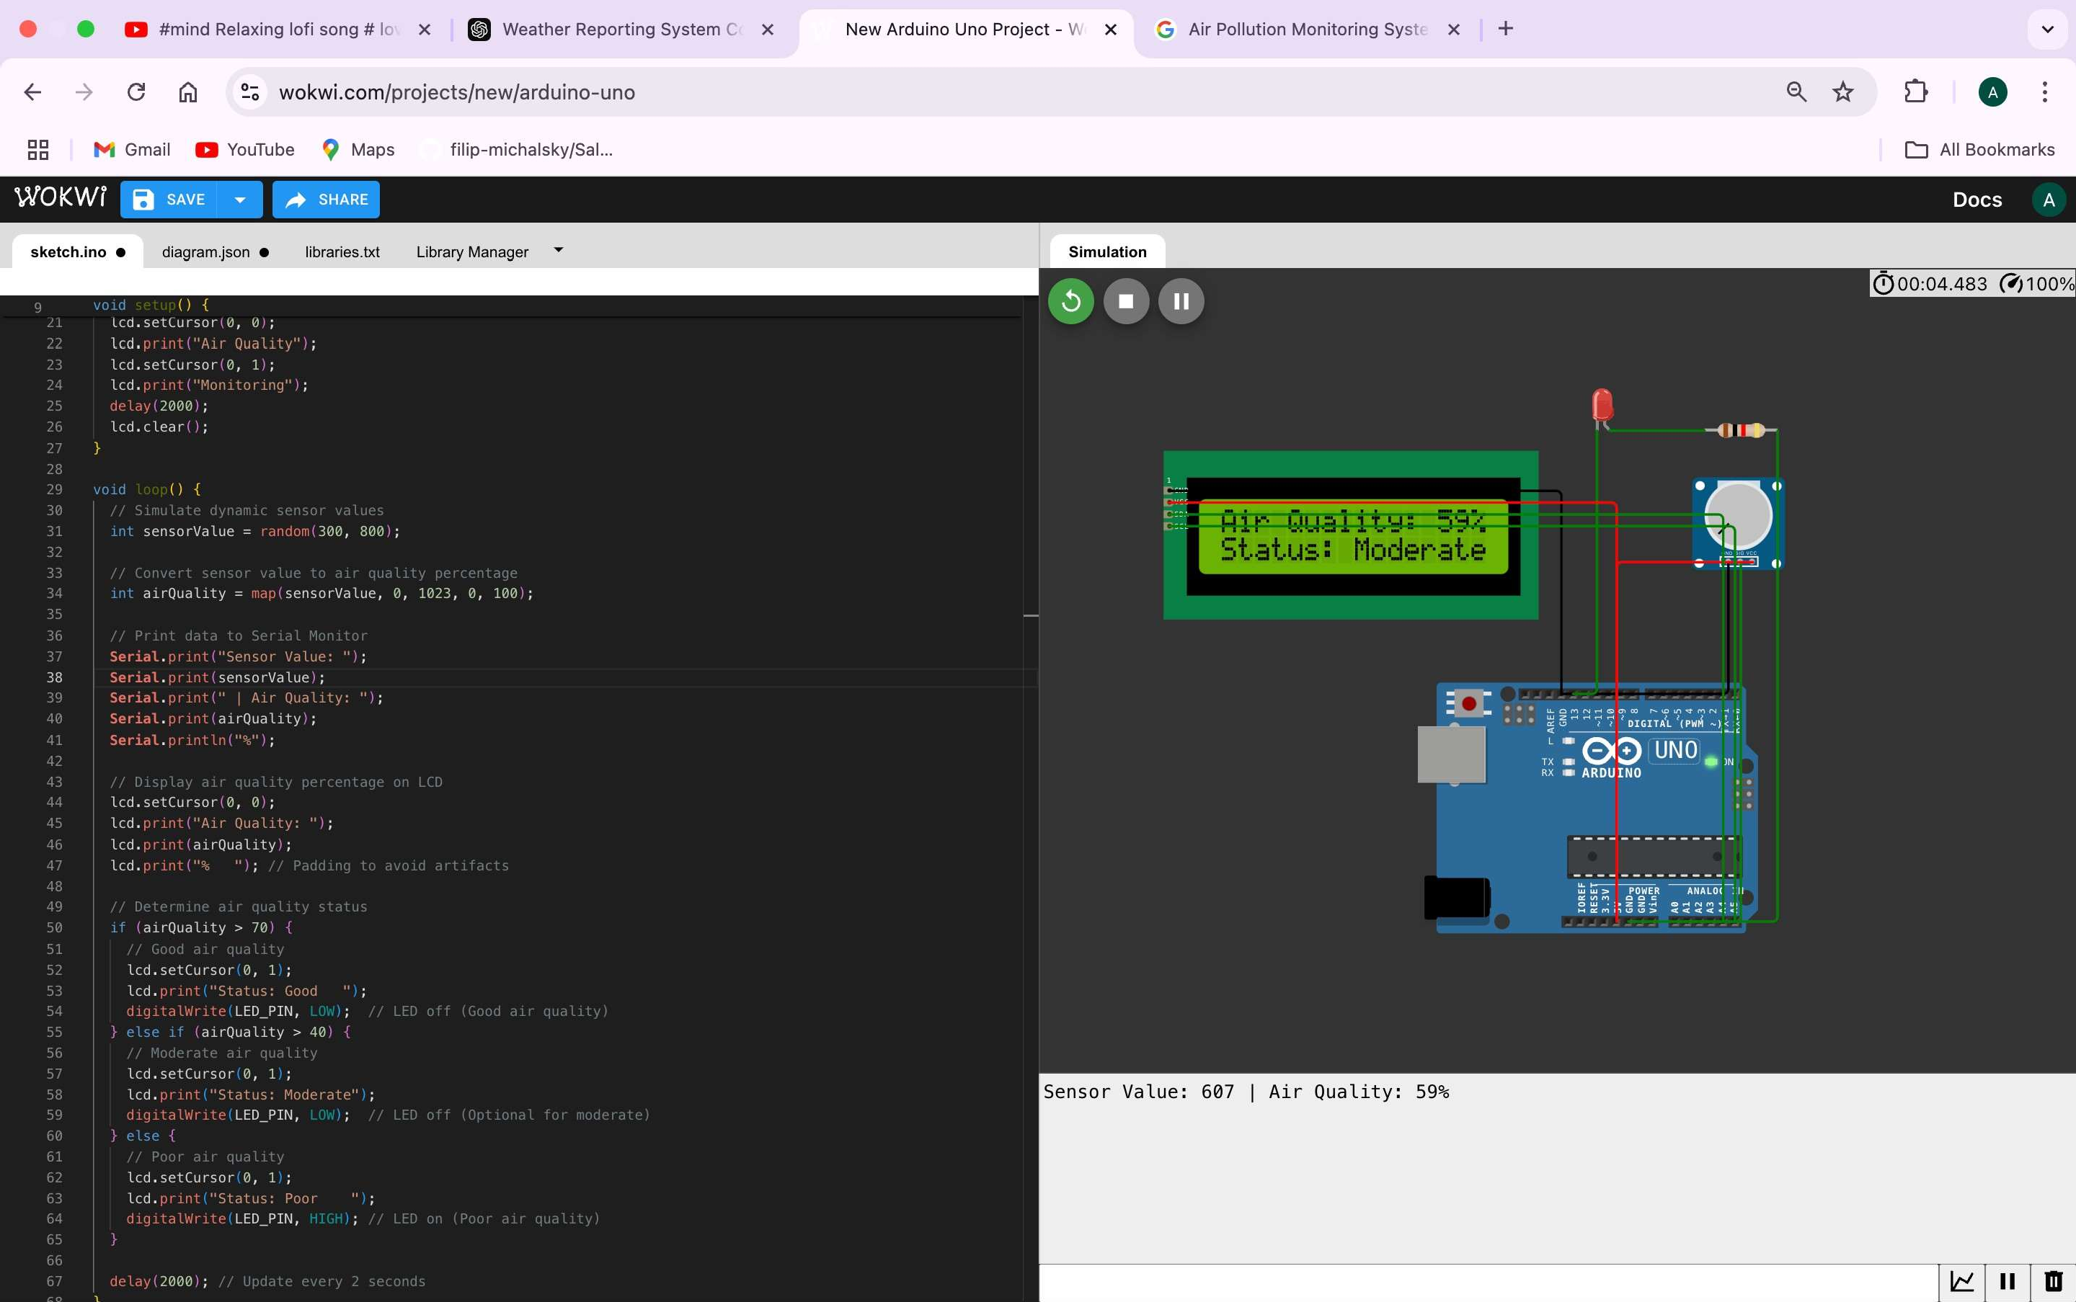

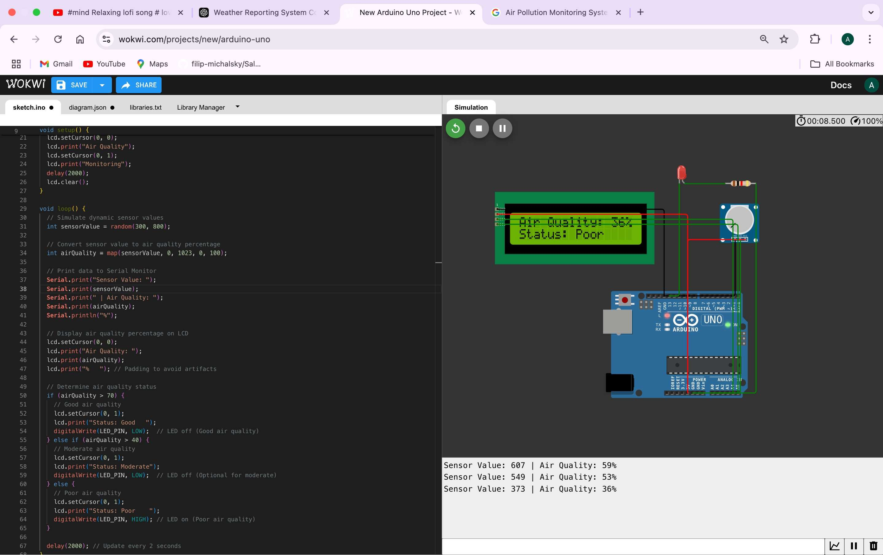

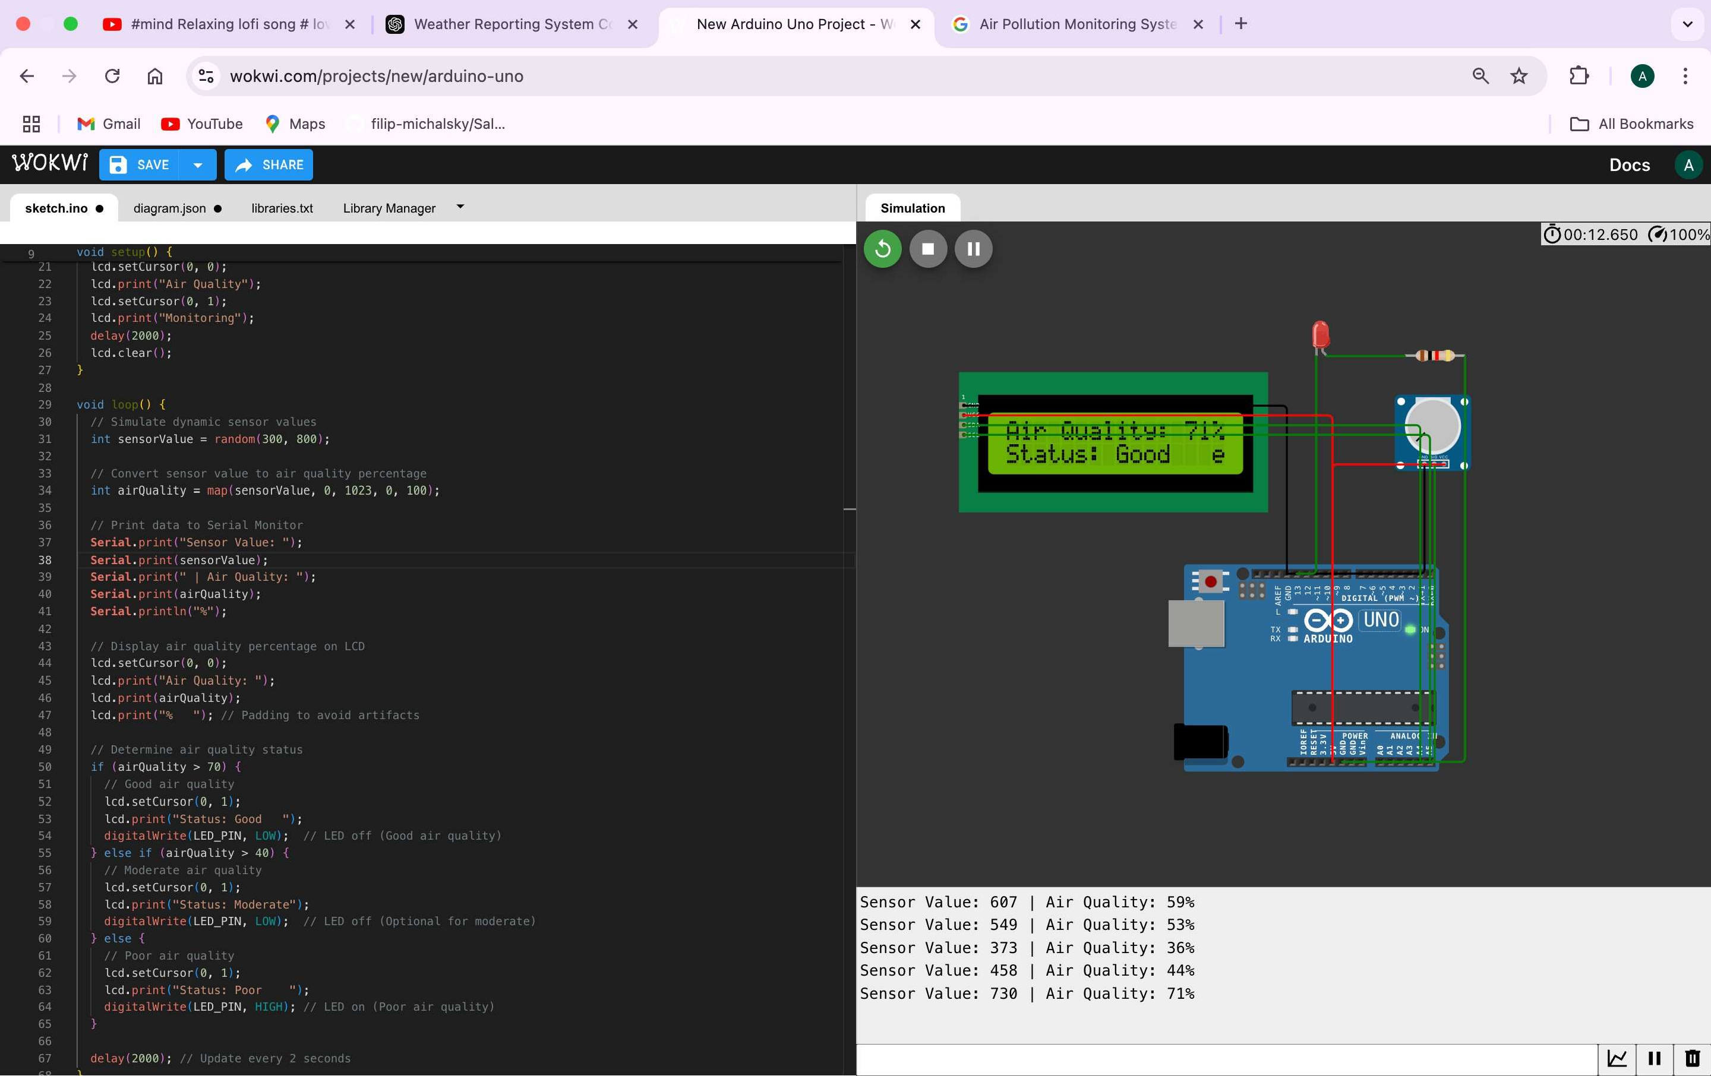

# Write a Embedded C Program to Create an loT-based Smart Irrigation System for Agriculture that automates watering based on weather and soil conditions.

#include <DHT.h> #include <Wire.h>

#include <LiquidCrystal_I2C.h>

#define DHT_PIN 2 // DHT sensor connected to pin 2 #define DHT_TYPE DHT22// Define DHT sensor type #define SOIL_PIN A0 // Soil moisture sensor connected to analog pin A0

#define RELAY_PIN 8 // Relay module connected to pin 8 #define MOISTURE_THRESHOLD 40 // Soil moisture threshold (%) #define TEMP_THRESHOLD 30 // Temperature threshold (°C)

DHT dht(DHT_PIN, DHT_TYPE); // Initialize DHT sensor

LiquidCrystal_I2C lcd(0x27, 16, 2); // Initialize LCD

void setup() {

// Initialize serial communication Serial.begin(9600);

// Initialize sensors and output devices dht.begin();

pinMode(SOIL_PIN, INPUT); pinMode(RELAY_PIN, OUTPUT);

digitalWrite(RELAY_PIN, LOW); // Ensure relay is off

// Initialize LCD lcd.begin(16, 2); lcd.backlight();

// Welcome message lcd.setCursor(0, 0); lcd.print("Smart Irrigation"); lcd.setCursor(0, 1); lcd.print("System Ready"); delay(2000);

lcd.clear();

}

void loop() {

// Read temperature and humidity from DHT sensor float temperature = dht.readTemperature();

float humidity = dht.readHumidity();

int soilValue = analogRead(SOIL_PIN);

int soilMoisture = map(soilValue, 1023, 0, 0, 100); // Convert to percentage

// Display readings on LCD lcd.setCursor(0, 0); lcd.print("Temp: "); lcd.print(temperature, 1); lcd.print("C Hum:"); lcd.print(humidity, 0); lcd.print("%");

lcd.setCursor(0, 1); lcd.print("Soil: "); lcd.print(soilMoisture); lcd.print("% ");

// Control irrigation based on conditions

if (soilMoisture < MOISTURE_THRESHOLD && temperature

> TEMP_THRESHOLD) {

digitalWrite(RELAY_PIN, HIGH); // Turn on pump lcd.print("PUMP ON");

Serial.println("Pump turned ON due to low soil moisture and high temperature.");

} else {

digitalWrite(RELAY_PIN, LOW); // Turn off pump lcd.print("PUMP OFF");

Serial.println("Pump turned OFF. Soil moisture or weather conditions are sufficient.");

}

// Log data to Serial Monitor Serial.print("Temperature: "); Serial.print(temperature);

Serial.print("C, Humidity: "); Serial.print(humidity); Serial.print("%, Soil Moisture: "); Serial.print(soilMoisture); Serial.println("%");

delay(2000); // Wait for 2 seconds before the next iteration

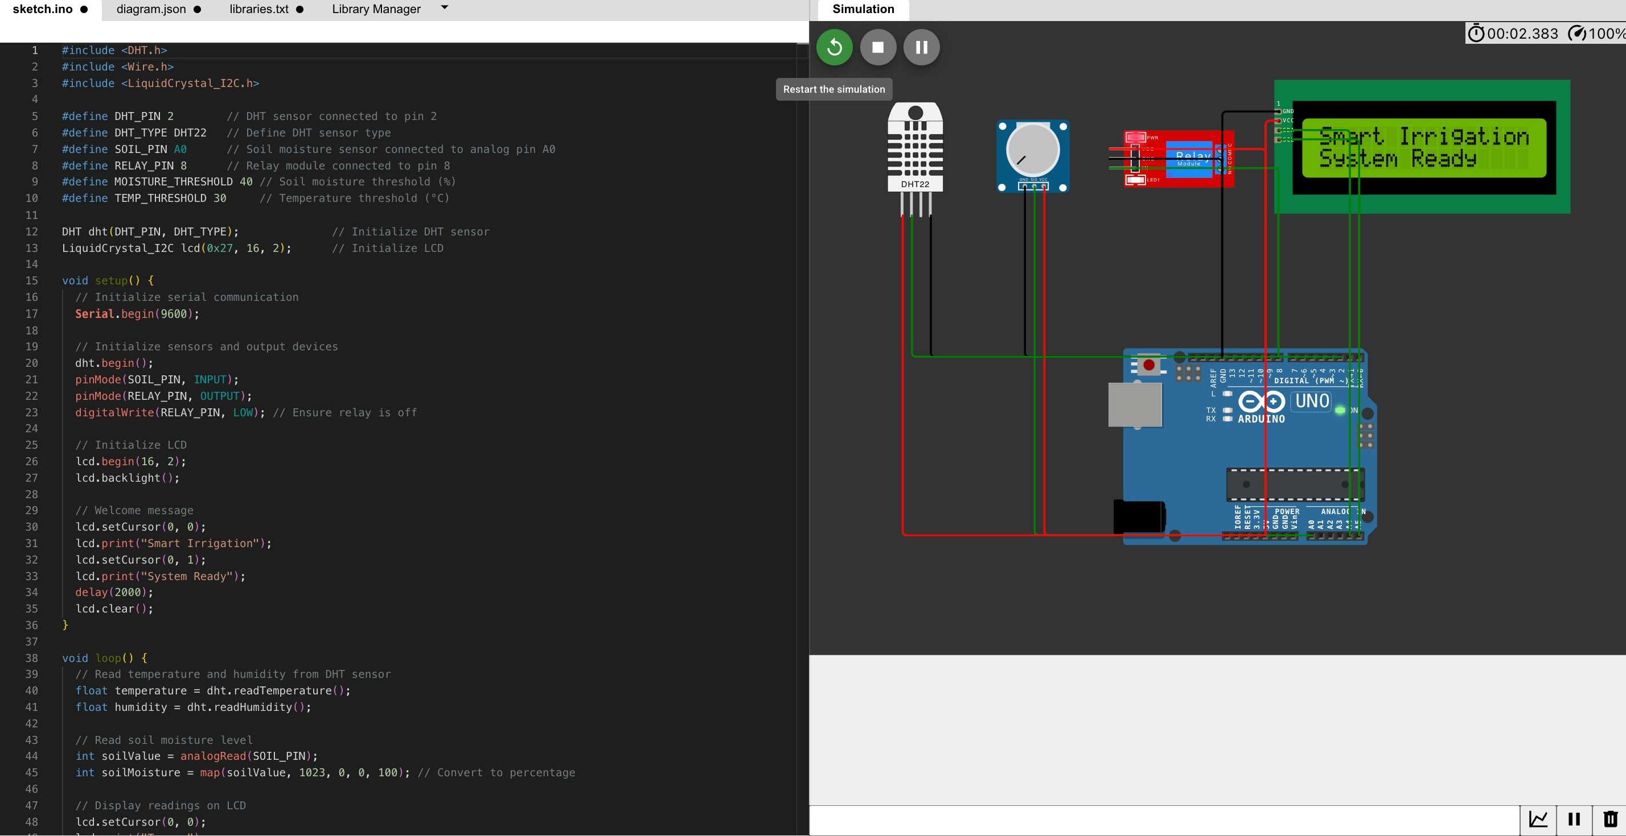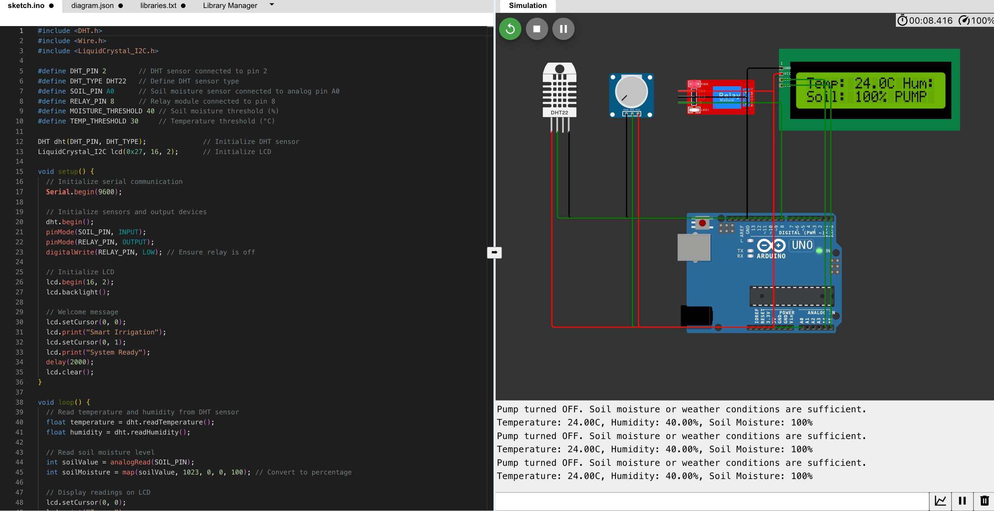}

# Write a Embedded C Program to Create a Smart Alarm Clock that adjusts to your schedule and environment, waking you up intelligently.

#include <Wire.h> #include <RTClib.h> #include <DHT.h>

#define DHT_PIN 2 // DHT sensor pin

#define DHT_TYPE DHT22 // Define DHT sensor type #define BUZZER_PIN 8 // Buzzer pin

#define TEMP_THRESHOLD 30 // Temperature threshold for early alarm (°C)

// Initialize RTC and DHT RTC_DS3231 rtc;

DHT dht(DHT_PIN, DHT_TYPE);

// Preset alarm time

int alarmHour = 6; // Alarm hour (24-hour format) int alarmMinute = 30; // Alarm minute

void setup() {

// Initialize Serial Monitor Serial.begin(9600);

// Initialize RTC if (!rtc.begin()) {

Serial.println("Couldn't find RTC"); while (1);

}

if (rtc.lostPower()) {

Serial.println("RTC lost power, setting time!");

rtc.adjust(DateTime(F( DATE ), F( TIME ))); // Set time to compile time

}

// Initialize DHT and Buzzer dht.begin(); pinMode(BUZZER_PIN, OUTPUT);

digitalWrite(BUZZER_PIN, LOW);

// Welcome Message

Serial.println("Smart Alarm Clock Initialized");

}

void loop() {

// Get current time DateTime now = rtc.now();

int currentHour = now.hour();

int currentMinute = now.minute();

// Read temperature

float temperature = dht.readTemperature();

// Display current time and temperature Serial.print("Current Time: "); Serial.print(currentHour); Serial.print(":"); Serial.println(currentMinute);

Serial.print("Temperature: "); Serial.print(temperature); Serial.println(" °C");

// Check if it's time to wake up

if (isAlarmTriggered(currentHour, currentMinute, temperature))

{

triggerAlarm();

} else {

digitalWrite(BUZZER_PIN, LOW); // Turn off alarm

}

delay(1000); // Wait for 1 second

}

// Function to check if the alarm should trigger

bool isAlarmTriggered(int hour, int minute, float temp) {

// Check if the current time matches the alarm time if (hour == alarmHour && minute == alarmMinute) { return true;

}

// Check if temperature is above threshold for early wake-up

if (temp > TEMP_THRESHOLD && hour == alarmHour && minute

== (alarmMinute - 10)) { return true;

}

return false;

}

// Function to trigger the alarm void triggerAlarm() {

Serial.println("Alarm Triggered! Wake up!"); digitalWrite(BUZZER_PIN, HIGH); // Turn on buzzer delay(500); // Alarm sound duration digitalWrite(BUZZER_PIN, LOW); // Turn off buzzer delay(500); // Pause between alarm

}

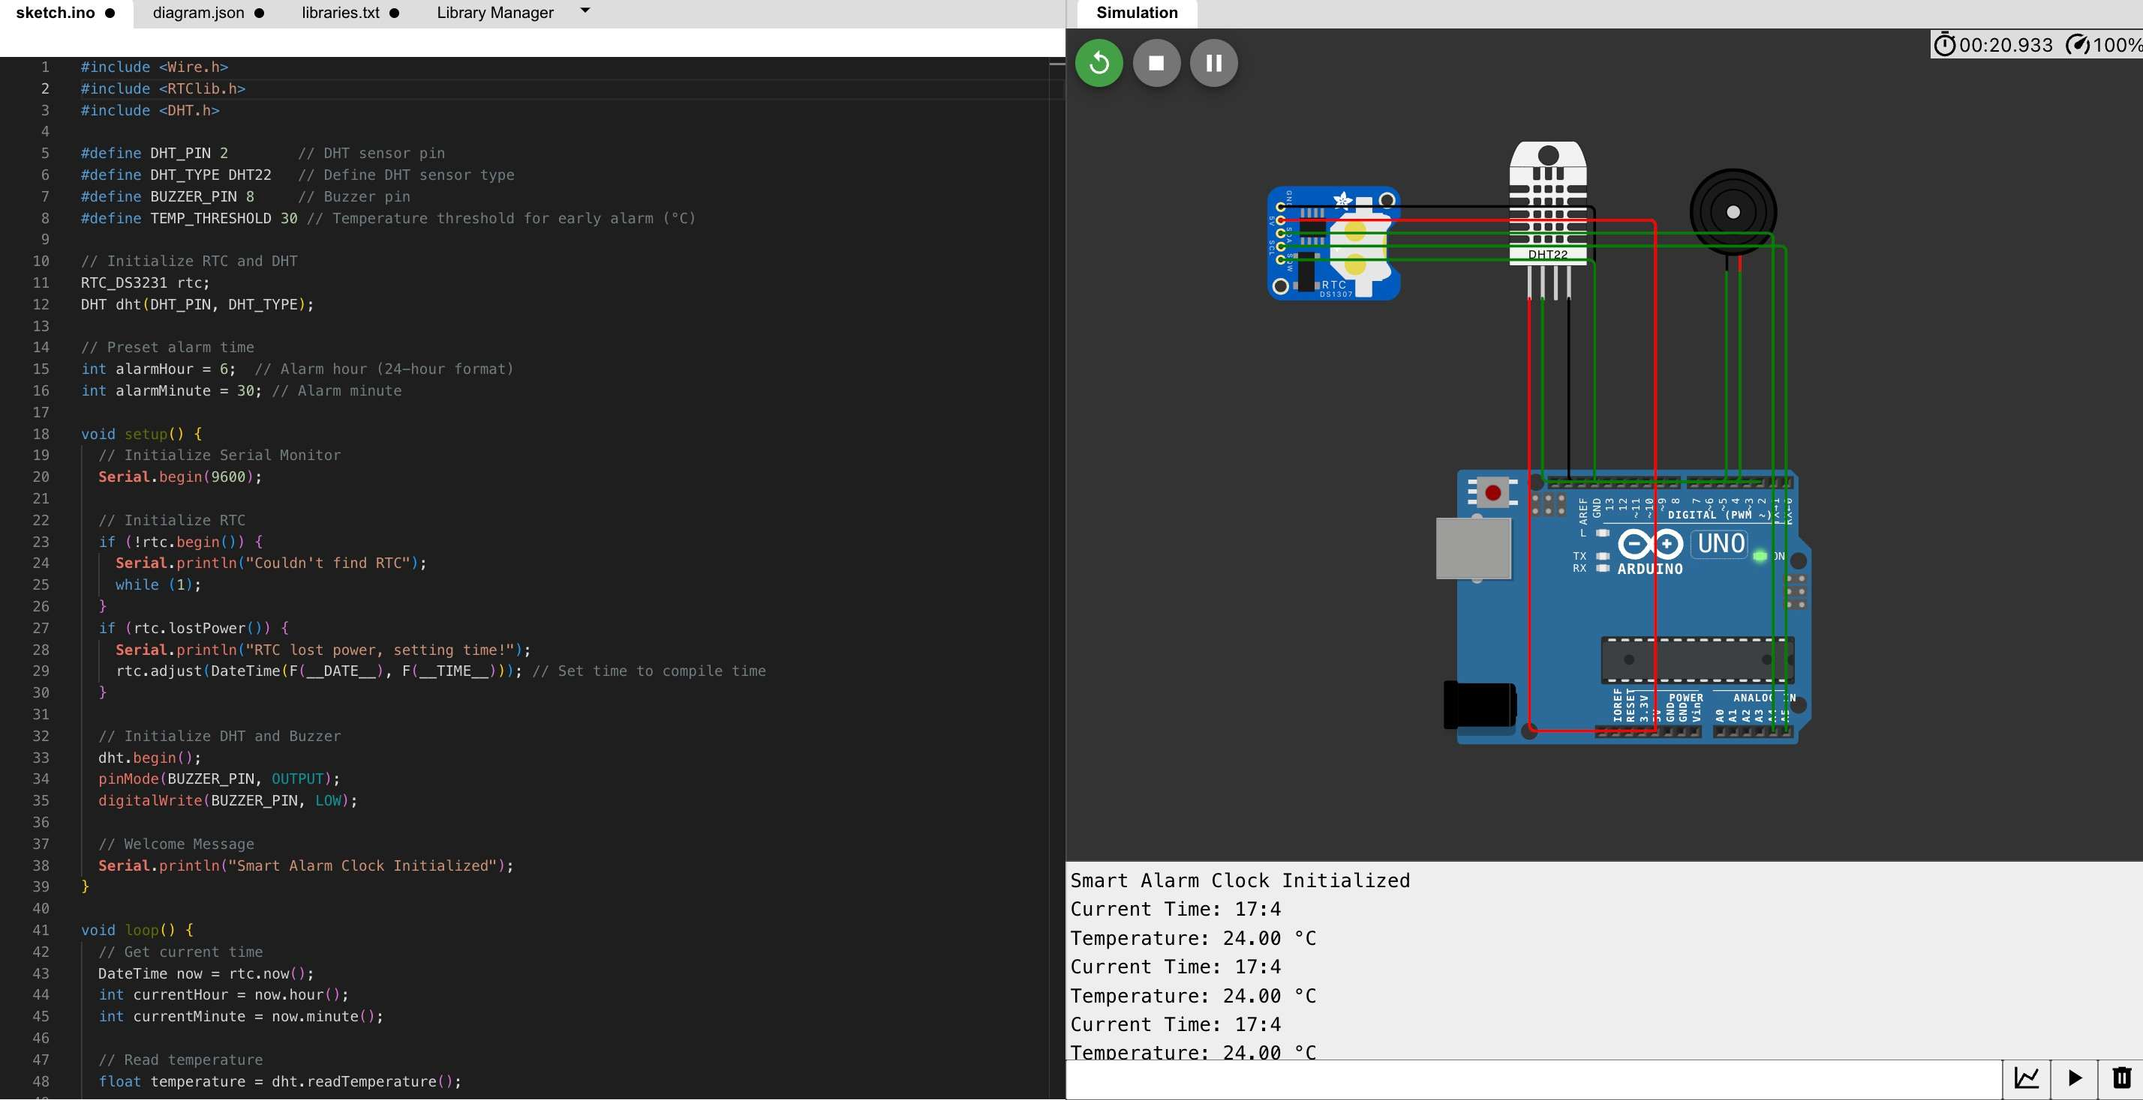

**Case Study**

# Interface a Camera Module to create an Attendance Monitoring System of Your Class Room.

### Components:

* 1. **ESP32-CAM Module** (with onboard camera).
  2. **FTDI Programmer** (for uploading code to ESP32-CAM).
  3. **MicroSD Card** (optional, for local storage of images).
  4. **Power Source** (5V supply or USB).

### Facial Recognition Software:

* + - Use prebuilt libraries like **OpenCV** or cloud APIs like **AWS Rekognition**, **Google Vision API**, or **Azure Face API**.

### Workflow:

1. **Capture Image**:
   * Use the ESP32-CAM to capture a student's image as they enter the classroom.

### Facial Recognition:

* + Compare the captured image with a preloaded database of student faces.
  + Identify the student and mark their attendance.

### Attendance Record:

* + Store the attendance log in a database (e.g., Firebase, MySQL) or on an SD card.

### Example Code for ESP32-CAM with Facial Recognition:

This example demonstrates basic face detection and capturing using the ESP32- CAM. Advanced recognition requires additional libraries or cloud integration.

#include <WiFi.h> #include

<esp_camera.h>

#include "soc/soc.h" // Disable brownout problems #include "soc/rtc_cntl_reg.h" // Disable brownout problems #include "esp_http_server.h" // For hosting web server

|  |  |
| --- | --- |
| // Camera Configuration |  |
| #define PWDN_GPIO_NUM | -1 |
| #define RESET_GPIO_NUM | -1 |
| #define XCLK_GPIO_NUM | 0 |
| #define SIOD_GPIO_NUM | 26 |
| #define SIOC_GPIO_NUM | 27 |

|  |  |
| --- | --- |
| #define Y9_GPIO_NUM | 35 |
| #define Y8_GPIO_NUM | 34 |
| #define Y7_GPIO_NUM | 39 |
| #define Y6_GPIO_NUM | 36 |
| #define Y5_GPIO_NUM | 21 |

define VSYNC_GPIO_NUM 25

#define HREF_GPIO_NUM 23

#define PCLK_GPIO_NUM 22

// Wi-Fi credentials

const char* ssid = "Your_SSID";

const char* password = "Your_PASSWORD";

void startCameraServer();

void setup() {

WRITE_PERI_REG(RTC_CNTL_BROWN_OUT_REG, 0); // Disable brownout detector

Serial.begin(115200); Serial.println();

camera_config_t config; config.ledc_channel = LEDC_CHANNEL_0; config.ledc_timer = LEDC_TIMER_0;

config.pin_d0 = Y2_GPIO_NUM; config.pin_d1

= Y3_GPIO_NUM;

config.pin_d2 = Y4_GPIO_NUM; config.pin_d3

= Y5_GPIO_NUM; config.pin_d4 = Y6_GPIO_NUM; config.pin_d5 = Y7_GPIO_NUM; config.pin_d6 = Y8_GPIO_NUM; config.pin_d7 = Y9_GPIO_NUM; config.pin_xclk = XCLK_GPIO_NUM; config.pin_pclk = PCLK_GPIO_NUM; config.pin_vsync = VSYNC_GPIO_NUM; config.pin_href = HREF_GPIO_NUM; config.pin_sscb_sda = SIOD_GPIO_NUM; config.pin_sscb_scl = SIOC_GPIO_NUM; config.pin_pwdn = PWDN_GPIO_NUM; config.pin_reset = RESET_GPIO_NUM; config.xclk_freq_hz = 20000000; config.pixel_format = PIXFORMAT_JPEG;

if (psramFound()) {

config.frame_size = FRAMESIZE_UXGA; config.jpeg_quality = 10;

config.fb_count = 2;

} else {

config.frame_size = FRAMESIZE_SVGA; config.jpeg_quality = 12;

config.fb_count = 1;

}

// Initialize the camera

esp_err_t err = esp_camera_init(&config); if (err != ESP_OK) {

Serial.printf("Camera init failed with error 0x%x", err); return;

}

// Connect to Wi-Fi WiFi.begin(ssid, password);

while (WiFi.status() != WL_CONNECTED) { delay(500);

Serial.print(".");

}

Serial.println(); Serial.println("WiFi connected");

// Start camera server startCameraServer();

Serial.println("Camera ready! Use 'http://' and IP to access"); Serial.println(WiFi.localIP());

}

void loop() {

// Camera stream runs via the web server

}

// Start a web server for live streaming void startCameraServer() {

httpd_config_t config = HTTPD_DEFAULT_CONFIG(); config.server_port = 80;

httpd_handle_t server = NULL;

if (httpd_start(&server, &config) == ESP_OK) { httpd_uri_t uri = {

.uri = "/",

.method = HTTP_GET,

.handler = stream_handler,

.user_ctx = NULL

};

httpd_register_uri_handler(server, &uri);

}

}

esp_err_t stream_handler(httpd_req_t *req) { camera_fb_t * fb = NULL;

esp_err_t res = ESP_OK;

fb = esp_camera_fb_get(); if (!fb) {

Serial.println("Camera capture failed"); httpd_resp_send_500(req);

return ESP_FAIL;

}

res = httpd_resp_send(req, (const char *)fb->buf, fb->len); esp_camera_fb_return(fb);

return res;

}

### Key Features of the Code:

1. **Live Streaming**:
   * You can view the camera feed via a browser.
   * The camera feed URL will be displayed in the serial monitor (e.g., [http://192.168.x.x).](http://192.168.x.x/)

### Integration:

* + Extend this project with facial recognition APIs (e.g., OpenCV or AWS Recognition) to identify individuals.

### Next Steps for Attendance System:

1. **Face Database**:
   * Preload student face data using a facial recognition library.

### Identify Students:

* + Match live faces to the database and mark attendance.

### Log Attendance:

* + Store attendance in a database (e.g., Firebase, MySQL).

### Notification:

* + Send attendance records via email or SMS using services like Twilio or SendGrid.

## IoT in Logistics and Fleet Management: Analyze how IoT technologies optimize logistics operations, from real-time tracking of shipments to predictive maintenance of transportation fleets.

### IoT in Logistics and Fleet Management: Optimization and Benefits

IoT (Internet of Things) technologies have revolutionized the logistics and fleet management industry, offering real-time insights, operational efficiency, and enhanced decision-making capabilities. Here's a detailed analysis of how IoT optimizes logistics operations:

### Real-Time Tracking of Shipments

* + **GPS Integration**:
    - IoT-enabled GPS trackers allow real-time tracking of shipments, ensuring visibility throughout the supply chain.
    - Provides accurate ETA (Estimated Time of Arrival) updates.

### RFID and Sensors:

* + - RFID tags track inventory movement across warehouses, distribution centers, and vehicles.
    - Sensors monitor temperature, humidity, and handling conditions for sensitive goods (e.g., pharmaceuticals, food).

### Geofencing:

* + - Alerts are triggered when a vehicle enters or exits predefined geographical boundaries.
    - Helps prevent unauthorized detours or theft.

**Example**: Amazon uses IoT to track and ensure on-time delivery by monitoring shipment routes and conditions.

### Fleet Monitoring and Management

* + **Vehicle Telemetry**:
    - IoT devices collect data from vehicle sensors to monitor speed, fuel consumption, engine health, and driver behavior.

### Driver Performance:

* + - Monitors driver habits (e.g., harsh braking, rapid acceleration) to improve safety and reduce fuel costs.
    - Helps identify training needs for drivers.

### Route Optimization:

* + - Real-time traffic and weather data enable dynamic rerouting for timely deliveries.
    - Reduces fuel consumption and operational costs.

**Example**: UPS’s ORION system uses IoT to optimize delivery routes, saving millions of gallons of fuel annually.

### Predictive Maintenance

* + **Sensor-Based Monitoring**:
    - IoT sensors continuously monitor key vehicle components like engines, brakes, and tires.
    - Detect early signs of wear and tear to schedule maintenance before breakdowns occur.

### Downtime Reduction:

* + - Proactive maintenance reduces unexpected downtime, ensuring the fleet stays operational.
    - Extends the lifespan of vehicles and reduces repair costs.

### Cost Savings:

* + - Avoids costly breakdowns during peak operations.

**Example**: DHL employs IoT sensors to monitor fleet health, reducing vehicle downtime and improving reliability.

### Warehouse and Inventory Management

* + **Smart Warehouses**:
    - IoT-connected devices automate inventory checks, reducing human error.
    - Tracks goods in real-time for accurate stock management and replenishment.

### Cold Chain Monitoring:

* + - Sensors ensure optimal temperature and humidity for perishable goods.
    - Sends alerts for deviations to prevent spoilage.

**Example**: Maersk uses IoT to monitor refrigerated containers for global shipments.

### Enhanced Customer Experience

* + **Transparency**:
    - Real-time tracking and updates keep customers informed about their shipments.

### Improved Delivery Accuracy:

* + - Predictive analytics based on IoT data ensures on-time delivery.

### Custom Alerts:

* + - Notifies customers of delays, route changes, or successful deliveries. **Example**: FedEx provides real-time shipment tracking via IoT and predictive analytics.

### Data Analytics and Insights

* + **Big Data Integration**:
    - IoT devices generate vast amounts of data for analytics.
    - Provides insights into operational bottlenecks, route efficiency, and resource utilization.

### Predictive Analytics:

* + - Forecasts demand, predicts peak periods, and optimizes resource allocation.

**Example**: Walmart uses IoT data analytics for inventory forecasting and logistics efficiency.

### Sustainability

* + **Fuel Efficiency**:
    - IoT-enabled route optimization reduces fuel consumption, lowering carbon emissions.

### Green Logistics:

* + - Sensors ensure efficient use of resources, reducing waste in operations.

### Electric Fleet Management:

* + - IoT integrates with EV (Electric Vehicle) fleets to monitor battery health and optimize charging schedules.

**Example**: Tesla’s IoT-enabled fleet tracks battery performance and charging stations for electric trucks.

### Challenges in IoT Implementation

1. **Data Security**:
   * Protecting sensitive data from cyberattacks is a critical concern.

### Integration Costs:

* + Upfront investment in IoT devices and infrastructure can be high.

### Interoperability:

* + Ensuring compatibility across diverse IoT devices and platforms.

## loT in Healthcare for Remote Patient Monitoring: examine the applications of loT in healthcare, specifically focusing on how it enables remote patient monitoring, improves healthcare delivery, and enhances patient outcomes.

### IoT in Healthcare for Remote Patient Monitoring: Applications and Impact

The Internet of Things (IoT) in healthcare has revolutionized patient care, particularly in **Remote Patient Monitoring (RPM)**. IoT enables real-time tracking of patient health data, facilitating timely interventions, enhancing healthcare delivery, and improving overall patient outcomes. Here's a detailed analysis:

### Key Applications of IoT in Remote Patient Monitoring

* 1. **Wearable Health Devices**
     + **Devices**: Smartwatches, fitness trackers, ECG monitors, blood pressure monitors, and pulse oximeters.

### Functionality:

* + - * Continuously monitor vital signs like heart rate, blood pressure, blood oxygen levels, and activity levels.
      * Provide real-time health data to both patients and healthcare providers.
    - **Benefits**: Early detection of abnormalities, allowing preventive care.

**Example**: Fitbit and Apple Watch monitor heart rate and detect atrial fibrillation.

### Chronic Disease Management

* + - **Diseases**: Diabetes, hypertension, asthma, and COPD (Chronic Obstructive Pulmonary Disease).

### IoT Tools:

* Glucose monitoring devices for diabetic patients.
* Smart inhalers to track asthma medication usage.

### Benefits:

* Reduces hospital visits by enabling patients to manage conditions at home.
* Alerts caregivers in case of critical health changes.

**Example**: Dexcom G6 provides real-time glucose levels to both patients and doctors.

### Post-Surgical Care

* + - **IoT Devices**: Smart patches, connected wound care systems.

### Functionality:

* + - * Monitor healing progress, infection indicators, and pain levels.
      * Send alerts for complications such as infections or excessive bleeding.
    - **Benefits**: Ensures better recovery outcomes and reduces the need for frequent follow-ups.

**Example**: VitalConnect’s VitalPatch monitors vitals during post-operative recovery.

### Elderly Care

* + - **IoT Systems**: Fall detection devices, GPS trackers, and smart medication dispensers.

### Functionality:

* + - * Detect falls or inactivity and send immediate alerts to caregivers or emergency services.
      * Remind elderly patients to take medications on time.
    - **Benefits**: Promotes independent living and ensures safety.

**Example**: Life Alert systems offer fall detection and emergency support.

### Hospital-at-Home Programs

* + - **IoT Role**:
* Connect hospital-grade devices to home settings.
* Enable remote monitoring of patients with conditions like heart failure or post-stroke care.

### Benefits:

* Reduces hospital admissions.
* Provides comfort by treating patients at home.

**Example**: Philips’ remote patient monitoring solutions integrate wearable devices with hospital EMR systems.

### How IoT Improves Healthcare Delivery

* 1. **Real-Time Data Transmission**
     + IoT devices transmit patient data to healthcare providers in real time.
     + Allows immediate response to critical situations like heart attacks or asthma attacks.

### Data-Driven Insights

* + - AI and Big Data analytics process IoT data to detect patterns and predict potential health issues.
    - Assists doctors in making informed decisions.

### Telemedicine Integration

* + - IoT devices complement telemedicine by providing accurate, real-time patient data.
    - Enables doctors to diagnose and treat patients remotely.

### Reduced Workload for Healthcare Providers

* + - Automation of routine health checks reduces the burden on hospital staff.
    - Allows healthcare providers to focus on critical cases.

### Enhancing Patient Outcomes

* 1. **Proactive and Preventive Care**
     + Continuous monitoring identifies early signs of disease progression.
     + Prevents complications through timely interventions.

### Personalized Treatment Plans

* + - IoT devices provide detailed health metrics, enabling tailored treatment.
    - Ensures medications and therapies are optimized for individual patients.

### Improved Medication Adherence

* + - Smart pill bottles and dispensers remind patients to take medications.
    - Monitors adherence and reports non-compliance to caregivers or doctors.

### Enhanced Patient Engagement

* + - IoT apps empower patients to track their own health metrics.
    - Encourages patients to actively participate in their healthcare journey.

### Better Chronic Disease Outcomes

* + - Reduced hospital admissions and emergency visits for chronic patients.
    - Improved quality of life through consistent monitoring and support.

### Challenges in IoT-Driven RPM

* 1. **Data Privacy and Security**
     + IoT devices are vulnerable to cyberattacks.
     + Ensuring compliance with regulations like HIPAA is critical.

### Interoperability Issues

* + - Lack of standardization makes it challenging to integrate IoT devices with existing healthcare systems.

### Cost and Accessibility

* + - High costs of IoT devices and infrastructure can limit adoption, particularly in low-resource settings.

### Reliability of Devices

* + - Device malfunctions or inaccuracies in data can impact patient care.

### Future Prospects

* **AI and IoT Integration**:
  + Enhanced predictive capabilities to foresee health risks.

### 5G Connectivity:

* + Faster and more reliable data transmission for real-time RPM.

### Blockchain for Security:

* + Improved data protection through decentralized data storage.

### Affordable IoT Solutions:

* + Increased accessibility in developing regions.

## loT and Augmented Reality for Enhanced Experiences: Exploring the convergence of IOT and augmented reality to create immersive and interactive experiences, such as AR-assisted maintenance or guided tours.

IoT and Augmented Reality for Enhanced Experiences

The convergence of Internet of Things (IoT) and Augmented Reality (AR) is revolutionizing various industries by creating immersive and interactive experiences. This synergy leverages IoT’s real-time data capabilities with AR’s visualization tools, enhancing user engagement, efficiency, and decision-making.

1. Key Applications of IoT and AR Integration
   1. AR-Assisted Maintenance and Repair
      * How It Works:
        + IoT-enabled sensors in machines and equipment collect real- time operational data.
        + AR devices (e.g., smart glasses, AR apps) overlay visual instructions or diagnostics on the equipment.
      * Applications:
        + Maintenance personnel can visualize machine performance data and identify faults instantly.
        + Step-by-step repair instructions appear as AR overlays, reducing the need for manuals or training.
      * Benefits:
        + Reduces downtime and repair errors.
        + Enhances efficiency, especially for complex machinery. Example: Boeing uses AR to guide technicians during airplane assembly and

maintenance, improving accuracy and speed.

* 1. Smart Guided Tours
     + How It Works:
       - IoT sensors in museums, historical sites, or tourist destinations detect visitor proximity and trigger AR experiences.
       - AR-enabled devices or apps provide interactive visual content, such as 3D reconstructions or historical narratives.
     + Applications:
       - Museums use AR to display lifelike 3D models of artifacts.
       - Tourist destinations showcase historical events or futuristic concepts overlaid on real-world views.
     + Benefits:
       - Engages visitors through interactive storytelling.
       - Provides personalized tours based on user preferences or location. Example: The British Museum integrates AR and IoT to create interactive exhibits for

an immersive visitor experience.

* 1. Industrial Training and Simulations
     + How It Works:
       - IoT devices simulate real-world operational conditions.
       - AR overlays guide trainees on performing tasks or handling machinery.
     + Applications:
       - Employee training in manufacturing, healthcare, or construction.
       - Emergency drills and simulations for safety protocols.
     + Benefits:
       - Provides hands-on learning experiences.
       - Reduces the cost and risk associated with real-world training. Example: Caterpillar uses AR and IoT for operator training on heavy equipment.
  2. Retail and Customer Experience
     + How It Works:
       - IoT sensors track product inventory and customer preferences.
       - AR devices provide personalized shopping experiences, such as trying virtual clothing or furniture.
     + Applications:
       - AR mirrors in fashion stores for virtual try-ons.
       - AR-enabled apps for visualizing products in home settings.
     + Benefits:
       - Enhances customer engagement and satisfaction.
       - Reduces product returns by providing accurate previews.

Example: IKEA’s AR app uses IoT data to let customers visualize furniture placement in their homes.

* 1. Smart Cities and Public Infrastructure
     + How It Works:
       - IoT devices collect data from urban infrastructure like roads, bridges, and utilities.
       - AR overlays show real-time conditions or provide navigation assistance.
     + Applications:
       - AR apps for city navigation, showing traffic congestion or nearby amenities.
       - Infrastructure maintenance teams use AR to view underground pipelines or wiring without excavation.
     + Benefits:
       - Improves urban planning and citizen experience.
       - Reduces maintenance costs and disruption.

Example: Singapore integrates IoT and AR to provide smart navigation and infrastructure insights for its residents.

* 1. Healthcare
     + How It Works:
       - IoT devices monitor patient health, while AR provides visualization for diagnosis or surgery.
     + Applications:
       - AR assists surgeons by overlaying anatomical data from IoT-connected medical devices.
       - IoT sensors in hospitals provide real-time data for AR-based diagnostics.
     + Benefits:
       - Enhances precision and reduces risks in complex procedures.
       - Improves patient understanding of diagnoses through visual aids. Example: AccuVein uses AR to visualize veins for blood draws, leveraging IoT data

for enhanced accuracy.

1. Benefits of IoT-AR Integration
   1. Enhanced Decision-Making
      * Combines IoT’s real-time data analytics with AR’s intuitive visualizations.
      * Empowers users to make informed decisions faster.
   2. Improved Operational Efficiency
      * Reduces manual effort by automating data collection and visualization.
      * Enhances accuracy in maintenance, training, and other applications.
   3. Personalization and Engagement
      * Offers interactive, tailored experiences for users based on IoT data inputs.
      * Increases user satisfaction and retention.
   4. Cost and Time Savings
      * Minimizes downtime in maintenance and training scenarios.
      * Reduces reliance on physical resources, like printed manuals or trainers.
2. Challenges in IoT-AR Integration
   1. High Implementation Costs
      * Initial investment in IoT devices, AR hardware, and integration systems can be expensive.
   2. Data Security and Privacy
      * IoT devices are vulnerable to cyberattacks, and AR systems often process sensitive data.
   3. Interoperability Issues
      * Ensuring seamless integration across diverse IoT devices and AR platforms can be challenging.
   4. User Training
      * Users may require training to effectively use AR devices and interpret IoT- driven visualizations.
3. Future Trends
   1. AI-Powered Insights
      * AI integration with IoT and AR will enable more advanced predictive analytics and automation.
   2. 5G Connectivity
      * Faster and more reliable data transmission will enhance real-time IoT-AR applications.
   3. Edge Computing
      * Processes data closer to the IoT device, reducing latency for AR overlays.
   4. Widespread Adoption
      * Reduced costs of IoT and AR technologies will drive adoption across smaller businesses and public sectors.

### Wearable loT Devices for Health and Fitness: Analyze the impact of wearable loT devices, such as fitness trackers and smartwatches, on personal health monitoring, exercise routines, and preventive healthcare

**Wearable IoT Devices for Health and Fitness: Impact on Personal Health Monitoring, Exercise, and Preventive Healthcare**

Wearable **Internet of Things (IoT)** devices, such as fitness trackers and smartwatches, have significantly transformed the landscape of **personal health monitoring**, **exercise routines**, and **preventive healthcare**. These devices offer real- time data collection, personalized insights, and advanced connectivity, enabling users to take proactive control over their health and well-being. Let’s analyze their impact across these areas:

### Impact on Personal Health Monitoring

* 1. **Continuous Health Monitoring**
     + **Devices**: Smartwatches (e.g., Apple Watch, Samsung Galaxy Watch), Fitness Trackers (e.g., Fitbit, Garmin).

### Functionality:

* + - * Wearables are equipped with sensors (heart rate monitors, accelerometers, GPS, gyroscopes) to collect real-time health data.
      * Track vitals such as **heart rate**, **blood oxygen levels (SpO2)**, **sleep patterns**, **calories burned**, and **physical activity**.

### Benefits:

* + - * **Early Detection of Health Issues**: Real-time monitoring can help detect irregularities like abnormal heart rates, atrial fibrillation, or irregular sleep patterns, allowing early intervention.
      * **Chronic Disease Management**: For conditions like **diabetes**, wearables can monitor blood glucose levels or activity, helping individuals track their health status and prevent complications.
      * **Peace of Mind**: Continuous health data helps users feel confident that their health is being tracked, potentially reducing anxiety and encouraging healthier choices.

**Example**: **Apple Watch** tracks heart rate and sends alerts if it detects an irregular rhythm, which could indicate atrial fibrillation (AFib).

### Impact on Exercise Routines

* 1. **Activity and Fitness Tracking**
     + **Devices**: Fitness trackers, smartwatches with integrated fitness apps.

### Functionality:

* + - * Track a wide range of physical activities, such as walking, running, swimming, cycling, and more.
      * Provide real-time feedback on workout progress, including distance, pace, calories burned, and duration.
      * Some wearables feature **GPS functionality** for tracking outdoor activities with high precision.

### Benefits:

* + - * **Personalized Exercise Plans**: Fitness trackers collect data on users' activity levels, and some devices can suggest personalized fitness goals, routines, or modifications to optimize performance.
      * **Motivation**: By setting daily goals and tracking progress, wearables encourage users to stay motivated and committed to their fitness journeys. The gamification of fitness (achievements, badges) also contributes to increased user engagement.
      * **Monitoring Intensity**: Wearables provide feedback on workout intensity (e.g., heart rate zones), allowing users to adjust exercise intensity to meet fitness goals (e.g., fat burning, cardiovascular fitness).

**Example**: **Fitbit Charge** tracks steps, active minutes, and heart rate, offering personalized insights to enhance fitness routines.

### Post-Exercise Recovery Monitoring

* + - **Devices**: Smartwatches and fitness trackers with recovery-related features.

### Functionality:

* + - * Some wearables monitor **recovery metrics** like heart rate variability (HRV), resting heart rate (RHR), and sleep quality to assess recovery after exercise.

### Benefits:

* + - * **Optimized Recovery**: Wearables help users understand their body’s recovery state, ensuring they rest appropriately and avoid overtraining.
      * **Improved Performance**: By tracking recovery, wearables help athletes and fitness enthusiasts strike the right balance between workout intensity and rest, leading to better overall performance.

**Example**: **Polar Vantage V2** provides detailed insights into recovery and readiness for the next workout using HRV and sleep data.

### Impact on Preventive Healthcare

* 1. **Early Detection of Health Risks**
     + **Devices**: Smartwatches, fitness trackers with health monitoring features.

### Functionality:

* + - * Constant monitoring of heart rate, blood oxygen saturation (SpO2), and other health metrics allows wearables to alert users to potential risks.
      * Devices can detect abnormal patterns, such as sudden spikes in heart rate, unusual sleep disturbances, or drastic changes in physical activity.

### Benefits:

* + - * **Prevention and Proactive Care**: Continuous monitoring offers valuable data for early detection of health risks such as cardiovascular issues, respiratory conditions, or mental health concerns.
      * **Reduced Healthcare Costs**: By catching issues early, wearable devices reduce the need for expensive emergency treatments and hospital visits.

**Example**: **Garmin Venu 2** tracks heart rate variability, providing insights into potential health risks, while some smartwatches offer **ECG functionality** to detect arrhythmias.

### Improving Chronic Disease Management

* + - **Devices**: Wearable glucose monitors, smartwatches with blood pressure tracking, ECG monitors.

### Functionality:

* + - * Some wearables are designed specifically for chronic disease management, such as continuous glucose monitors for diabetes or wearables that track blood pressure.
      * These devices transmit data to healthcare providers, allowing for remote monitoring and ensuring timely medical interventions.
      * **Better Control of Chronic Conditions**: Users can manage conditions like diabetes, hypertension, and heart disease more effectively through continuous, real-time data.
      * **Remote Monitoring**: Healthcare providers can remotely track their patients’ health status, enabling timely adjustments to treatment plans and improving patient outcomes.

**Example**: **Dexcom G6** is a continuous glucose monitoring system that integrates with wearables to track glucose levels in real-time, helping users manage diabetes more effectively.

### Enhanced Mental Health Monitoring

* + - **Devices**: Wearables with heart rate variability (HRV) and stress tracking features.

### Functionality:

* + - * Some wearables monitor **stress levels** and **mood fluctuations** by tracking physiological indicators like HRV, heart rate, and even skin temperature.
      * Integration with mental health apps allows users to gain insights into their emotional states and recommend mindfulness or relaxation techniques.

### Benefits:

* + - * **Early Intervention for Mental Health Issues**: Wearables can identify early signs of stress, anxiety, or depression, encouraging users to take proactive measures such as breathing exercises or seeking professional help.
      * **Holistic Wellness**: By tracking both physical and mental health metrics, wearables provide a more complete picture of overall well-being.

**Example**: **Oura Ring** tracks HRV and sleep, providing insights into stress levels and recovery to enhance mental and physical health.

### Challenges and Considerations

* 1. **Data Accuracy and Reliability**
     + Wearable devices must provide accurate and reliable health data to be truly beneficial. Inaccuracies in measurements (e.g., heart rate or step count) could lead to misleading health insights.

### Battery Life

* + - Continuous health and fitness tracking can drain battery life quickly, limiting usage to short periods before recharging is needed.

### Privacy and Security

* + - IoT-enabled wearables collect vast amounts of personal data, including sensitive health information. Ensuring secure data transmission and user privacy is crucial to gaining user trust.

### Integration with Healthcare Systems

* + - Seamless integration between wearable devices and healthcare systems (e.g., Electronic Health Records) is necessary for optimal use in preventive healthcare.